**ABSTRACT**

Internet of things (IOT) is a concept where different devices or objects are connected to each other through the internet. Basically, an ecosystem is formed through things that is accessible to the internet. The ‘thing’ in IoT could be a person with a heart monitor or an automobile with built-in-sensors, i.e. objects that have been assigned an IP address and have the ability to collect and transfer data over a network without manual assistance or intervention. The embedded technology in the objects helps them to interact with internal states or the external environment, which in turn affects the decisions taken.

Home automation is concept of "The Internet of Things,". Devices and appliances can be networked together to provide us with seamless control over all aspects of our home and more. Home automation has been around for many decades in terms of lighting and simple appliance control. Recently technology caught up with the idea of the interconnected world at the touch of your fingertips or a simple voice command to Alexa, Google Assistant, Siri, and Cortana. The dream of making your home smart is now a reality. Smart Home and home automation are quite interchangeable, in fact, if you research what is a smart home most of the same results will appear.

|  |  |  |  |
| --- | --- | --- | --- |
|  | **Table of Contents** |  |  |
| Title Page | | 1 |  |
| About the company | | 2 |  |
| Certificates | | 3-6 |  |
| Acknowledgement | | 7 |  |
| Abstract | | 8 |  |
| Chapter 1: | | 10 |  |
| Introduction | | 10 |  |
| Benefits of IOT | | 10 |  |
| Diagram | | 11 |  |
| Chapter 2: | | 12 |  |
| 2 Theory | | 12 |  |
| 2.1 | How IOT is changing the world | 12 |  |
| 2.2 | How IOT is implemented | 13 |  |
| 2.3 | Sensors used in IOT project | 14 |  |
| Chapter 3: | | 15 |  |
| 3.1 | Problem | 15 |  |
| 3.2 | About the Project | 15 |  |
| 3.3 | Materials Used | 15 |  |
| Chapter 4: | | 16 |  |
| 4.1 | The making of the Project | 16 |  |
| 4.2 | About the components | 16 |  |
| 4.3 | What to know before running the project | 17 |  |
| 4.4 | The Working of the Project | 18 |  |
| 4.5 | Circuit Diagram | 22 |  |
| Chapter 5: | | 24 |  |
|  |  |
| Results and Discussions | |  |  |
| 5.1 | Result | 27 |  |
| 5.2 | Error Handling and Debugging Part | 27 |  |
| 5.3 | Project links on github and Youtube | 27 |  |
| Chapter 6: | | 27 |  |
|  |  |
| Conclusions and Scope of Future Study | | 28 |  |

References

29

**CHAPTER: 1**

**INTRODUCTION**

Internet of things (IOT) is a concept where different devices or objects are connected to each other through the internet. Basically, an ecosystem is formed through things that is accessible to the internet. The ‘thing’ in IoT could be a person with a heart monitor or an automobile with built-in-sensors, i.e. objects that have been assigned an IP address and have the ability to collect and transfer data over a network without manual assistance or intervention. The embedded technology in the objects helps them to interact with internal states or the external environment, which in turn affects the decisions taken.

The IoT is significant because an object that can represent itself digitally becomes something greater than the object by itself. No longer does the object relate just to its user, but it is now connected to surrounding objects and database data. When many objects act in unison, they are known as having "ambient intelligence."

The training undergone by me was a very experimental one. I was exposed to not only theory but mainly to the practical world. So, it turned to be a very interesting one. IOT is not only evolving in todays world but also making a huge impact on our lives these days.

**Benefits of IoT**

The internet of things offers several benefits to organizations, enabling them to:

* monitor their overall business processes;
* improve the customer experience;
* save time and money;
* enhance employee productivity;
* integrate and adapt business models;
* make better business decisions; and
* generate more revenue.

IoT encourages companies to rethink the ways they approach their businesses, industries and markets and gives them the tools to improve their business strategies.

**DIAGRAMATICALLY DEPECTING THE SCOPES OF IOT :-**

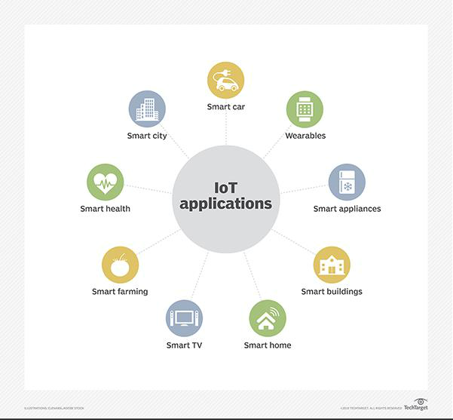

**CHAPTER: 2**

**THEORY**

**2.1 HOW IOT IS CHANGING THE WORLD:**

Everybody talks about the Internet of Things, the IoT but how is the IoT going to change our lives?

The Internet of Things is creating a new world, a quantifiable and measurable world, where people and businesses can manage their assets in better informed ways and can make more timely and better informed decisions about what they want or need to do. By sensing our surrounding environment, the IoT will create many practical improvements in our world, increasing our convenience, health and safety, while at the same time improving energy efficiency and comfort. The IoT will be a new source of wealth creation.

IoT devices are classified in three categories:

Wearables: Wearables are the devices that people carry with them, which usually connect via Bluetooth to a smart phone, and from there to the Internet. This category includes devices such as smart watches, fitness bands and devices to help people to live more mindfully increasing the wearer’s awareness of how well they sleep, how much they move around, monitoring their vital signs, etc.

Smart Home Devices: Smart home devices are also part of the IoT and usually connect to the Internet via ZigBee low power wireless communication and the home router. These include all domestic devices, from lights and light switches to motion sensors, thermostats, door locks and automated curtains. Via its Wi-Fi connection to the router, the smart phone also becomes an online dashboard and control device for Smart Home applications.

M2M Device: M2M (Machine to Machine) devices, comprises devices that are directly connected to the cellular network, such as cars that can report their location in case of an accident or theft, or vending machines that can call in when their stocks are running low.

The growth of the IoT can be compared with the growth of the automobile industry. Picture the first cars hitting the road: there were no freeways, no road signs, no rules, no driving licenses. Pedestrians did not know to get out of the way. Drivers did not know how to take turns at intersections. Neither drivers nor pedestrians understood the risks and liabilities, giving no consideration to liability and insurance.

The IoT will change the world in an even more profound way than has the Internet. If we ask someone today how the world existed before Internet, they are speechless. They have no comprehension of how

people could communicate or even live their lives without the common place tools we have today. The same will happen with the IoT.

**2.2 HOW IOT IS IMPLEMENTED:**

Different microcontroller boards are used such as:

1. Arduino Board

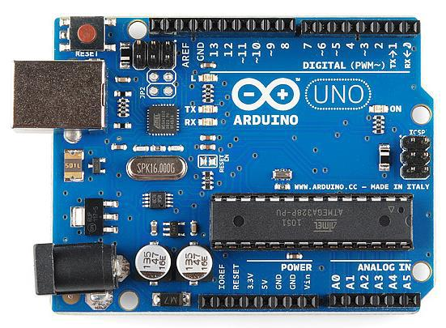

2. Raspberry Pi :

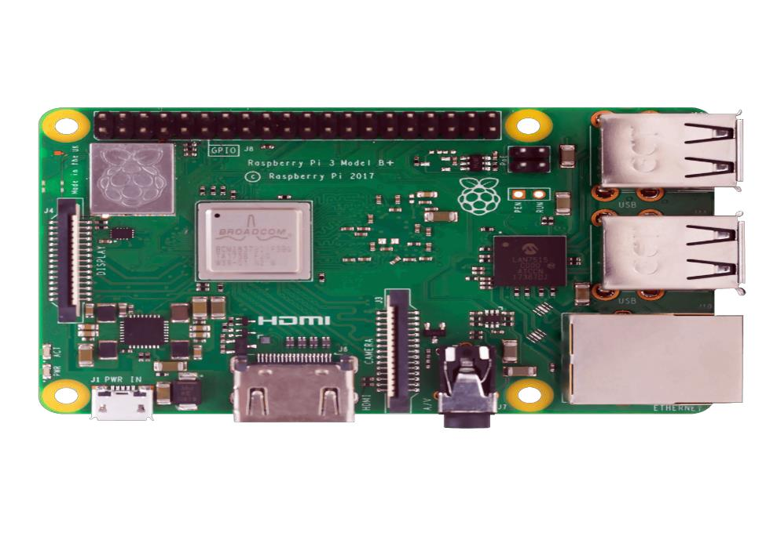

**2.3 SENSORS USED IN IOT PROJECTS:**

Sensors can be grouped using several criteria:

* Passive or Active. Passive sensors do not require an external power source to monitor an environment, while Active sensors require such a source in order to work.
* Another classification is based on the method used to detect and measure the property (mechanical, chemical, etc.).
* Analog and Digital. Analog sensors produce an analog, or continuous, signal while digital sensors produce a discrete signal.

Some examples of sensors are

* Temperature Sensors. ...
* Proximity Sensor. ...
* Pressure Sensor. ...
* Water Quality Sensor. ...
* Chemical Sensor. ...
* Gas Sensor. ...
* Smoke Sensor. ...

And many more.

**PART-II**

**CHAPTER 3:**

**PROJECT WORK**

**3.1 PROBLEM:**

In todays world privacy is the most widespread concern. So, my problem statement during the training was to develop a system to secure and make the whole access control systems automated and more secure and less cumbersome.

**3.2 ABOUT THE PROJECT:**

This project is “Anti-Theft Home Automation“. This project is primely developed to make the whole locking/unlocking system, lighting and cameras autonomous and less cumbersome.

**3.3 MATERIALS USED:**

* Arduino Uno
* Bluetooth Module HC-05
* Windows Platform
* LEDs, Resistors
* Camera
* Android device
* Buzzer
* LDR
* PIR Sensor
* Jumper wires
* Servo Motor

Note : The aforementioned components are defined below in the next part.

**3.4 SOFTWARES USED :**

* Arduino IDE:

The Arduino integrated development environment (IDE) is a cross-platform application (for Windows, macOS, Linux) that is written in the programming language Java. It is used to write and upload programs to Arduino compatible boards, but also, with the help of 3rd party cores, other vendor development boards.

The source code for the IDE is released under the GNU General Public License, version 2. The Arduino IDE supports the languages C and C++ using special rules of code structuring. The Arduino IDE supplies a software library from the Wiring project, which provides many common input and output procedures. User-written code only requires two basic functions, for starting the sketch and the main program loop, that are compiled and linked with a program stub main() into an executable cyclic executive program with the GNU toolchain, also included with the IDE distribution. The Arduino IDE employs the program avrdude to convert the executable code into a text file in hexadecimal encoding that is loaded into the Arduino board by a loader program in the board's firmware.

* MIT App Inventor :

MIT App Inventor is an intuitive, visual programming environment that allows everyone – even children – to build fully functional apps for smartphones and tablets. Those new to MIT App Inventor can have a simple first app up and running in less than 30 minutes. And what's more, our blocks-based tool facilitates the creation of complex, high-impact apps in significantly less time than traditional programming environments. The MIT App Inventor project seeks to democratize software development by empowering all people, especially young people, to move from technology consumption to technology creation.

**CHAPTER 4:**

**METHODOLOGY ADOPTED**

**4.1 THE MAKING OF THE PROJECT:**

A tiny model is made of a small house using crafting materials that could intake a few sensors, lights and a buzzer. The Arduino Uno is connected to all the sensors using jumper wires. The Arduino Uno is powered with the digital machine itself (A laptop) and can also be powered with a 9-V battery as it accepts voltage from 7V to 20V.

Servo Motors are great components to work with while making projects though they aren’t used in practical implementation. Servo is used in order to operate the doors of the model. The servo begins working when it receives signals from the Arduino.

The LDR (Light Dependent Resistor) is used to detect light coming from the sun in order to automate the switching off of lights when its no longer dark outside. This component has a variable resistance that changes with the amount or intensity of Light that it receives.

The PIR sensor( Passive Infrared sensor) is an electronic sensor that measures IR light radiating from different objects in its field of view. They are called passive because they themselves doesn’t radiate any kind of energy. They work entirely by detecting infrared radiation (radiant heat) emitted by or reflected from objects. This sensor is one of the fundamental device in making of the Anti-Theft system of the house.

Similarly, various lights and buzzers are attached to the model that would get activated after detecting certain activities.

**4.2 ABOUT THE COMPONENTS :**

**1. Arduino Uno :**

The Arduino UNO is an open-source microcontroller board based on the Microchip ATmega328P microcontroller and developed by Arduino.cc. The board is equipped with sets of digital and analog input/output (I/O) pins that may be interfaced to various expansion boards (shields) and other circuits. The board has 14 Digital pins, 6 Analog pins, and programmable with the Arduino IDE (Integrated Development Environment) via a type B USB cable. It can be powered by the USB cable or by an external 9-volt battery, though it accepts voltages between 7 and 20 volts. It is also similar to the Arduino Nano and Leonardo. The hardware reference design is distributed under a Creative Commons Attribution Share-Alike 2.5 license and is available on the Arduino website. Layout and production files for some versions of the hardware are also available.

1. **Servo Motor :**

A servomotor is a rotary actuator or linear actuator that allows for precise control of angular or linear position, velocity and acceleration. It consists of a suitable motor coupled to a sensor for position feedback. It also requires a relatively sophisticated controller, often a dedicated module designed specifically for use with servomotors.

Servomotors are not a specific class of motor although the term servomotor is often used to refer to a motor suitable for use in a closed-loop control system.

Servomotors are used in applications such as robotics, CNC machinery or automated manufacturing.

1. **PIR Sensor :**

A passive infrared sensor (PIR sensor) is an electronic sensor that measures infrared (IR) light radiating from objects in its field of view. They are most often used in PIR-based motion detectors. PIR sensors are commonly used in security alarms and automatic lighting applications. PIR sensors detect general movement, but do not give information on who or what moved. For that purpose, an active IR sensor is required.

PIR sensors are commonly called simply "PIR", or sometimes "PID", for "passive infrared detector". The term passive refers to the fact that PIR devices do not radiate energy for detection purposes. They work entirely by detecting infrared radiation (radiant heat) emitted by or reflected from objects.

1. **LDR**

A photoresistor (or light-dependent resistor, LDR, or photo-conductive cell) is a light-controlled variable resistor. The resistance of a photoresistor decreases with increasing incident light intensity; in other words, it exhibits photoconductivity. A photoresistor can be applied in light-sensitive detector circuits, and light-activated and dark-activated switching circuits.

A photoresistor is made of a high resistance semiconductor. In the dark, a photoresistor can have a resistance as high as several megohms (MΩ), while in the light, a photoresistor can have a resistance as low as a few hundred ohms. If incident light on a photoresistor exceeds a certain frequency, photons absorbed by the semiconductor give bound electrons enough energy to jump into the conduction band. The resulting free electrons (and their hole partners) conduct electricity, thereby lowering resistance. The resistance range and sensitivity of a photoresistor can substantially differ among dissimilar devices. Moreover, unique photoresistors may react substantially differently to photons within certain wavelength bands.

A photoelectric device can be either intrinsic or extrinsic. An intrinsic semiconductor has its own charge carriers and is not an efficient semiconductor, for example, silicon. In intrinsic devices the only available electrons are in the valence band, and hence the photon must have enough energy to excite the electron across the entire bandgap. Extrinsic devices have impurities, also called dopants, added whose ground state energy is closer to the conduction band; since the electrons do not have as far to jump, lower energy photons (that is, longer wavelengths and lower frequencies) are sufficient to trigger the device. If a sample of silicon has some of its atoms replaced by phosphorus atoms (impurities), there will be extra electrons available for conduction. This is an example of an extrinsic semiconductor.

1. **LED :**

A light-emitting diode (LED) is a semiconductor light source that emits light when current flows through it. Electrons in the semiconductor recombine with electron holes, releasing energy in the form of photons. This effect is called electroluminescence.The color of the light (corresponding to the energy of the photons) is determined by the energy required for electrons to cross the band gap of the semiconductor. White light is obtained by using multiple semiconductors or a layer of light-emitting phosphor on the semiconductor device.

Appearing as practical electronic components in 1962, the earliest LEDs emitted low-intensity infrared light. Infrared LEDs are used in remote-control circuits, such as those used with a wide variety of consumer electronics. The first visible-light LEDs were of low intensity and limited to red. Modern LEDs are available across the visible, ultraviolet, and infrared wavelengths, with high light output.

Early LEDs were often used as indicator lamps, replacing small incandescent bulbs, and in seven-segment displays. Recent developments have produced high-output white light LEDs suitable for room and outdoor area lighting. LEDs have led to new displays and sensors, while their high switching rates are useful in advanced communications technology.

LEDs have many advantages over incandescent light sources, including lower energy consumption, longer lifetime, improved physical robustness, smaller size, and faster switching. Light-emitting diodes are used in applications as diverse as aviation lighting, automotive headlamps, advertising, general lighting, traffic signals, camera flashes, lighted wallpaper and medical devices.

Unlike a laser, the color of light emitted from an LED is neither coherent nor monochromatic, but the spectrum is narrow with respect to human vision, and functionally monochromatic.

1. **Bluetooth Module HC-05**

HC‐05 module is an easy to use Bluetooth SPP (Serial Port Protocol) module is designed for transparent wireless serial connection setup. The HC-05 Bluetooth Module can be used in a Master or Slave configuration, making it a great solution for wireless communication.

This serial port bluetooth module is fully qualified Bluetooth V2.0+EDR (Enhanced Data Rate) 3Mbps Modulation with complete 2.4GHz radio transceiver and baseband. It uses CSR Bluecore 04‐External single chip Bluetooth system with CMOS technology and with AFH (Adaptive Frequency Hopping Feature).

**4.3 WHAT TO KNOW BEFORE RUNNING THE PROJECT:**

* To run the project, all the sensors and components are need to be attached to the Arduino according to the circuit diagram given below.
* The correct model of sensors and Arduino should be used while implementing in order to get the best results.
* The Arduino should be powered with 9V of battery power or a machine (A Laptop).
* Arduino Uno software should be installed in the machine and proper code is to be uploaded to the Arduino in order to make all the sensors operate in a sequential way.
* A proper Android App is mandatory that can connect with the Bluetooth Module which is connected to the Arduino so that the Arduino receives proper bits of data to operate on the command of the Android device.
* The code for the project is given in the link below and the project is also uploaded in Youtube with the Github link in the description.
* The Android App is also uploaded in the GitHub link.

**4.4 THE WORKING OF THE PROJECT:**

* Every component in the model is automated. Starting from the lights to the doors of the model is secured and needs your permission through your android device in order to operate.
* The lights have the functionality to operate on command of the android device. An Android app is programmed that have the capability to turn the lights on or off.
* It is not limited to the android device, that is, the lights are also controlled by an LDR sensor.
* The LDR sensors helps in detecting light from outside the house so that it can figure it out if it is still dark outside. If not, it triggers the lights to get on or off according to the data it is receiving.
* Apart from the lights, the door of the model is password protected. The Android App asks you to connect to the Bluetooth module present inside the model.
* Once you are connected, it asks you a password which further opens the door automatically for you if the entered password matches with the stored password.
* The model also consists of a PIR sensor. The Android App has a secure mode. When the secure mode is activated, the PIR sensor starts detecting radiant heat. In absence of the House owner, if anybody is found inside the house, a buzzer is activated along with a camera that records the whole incident taking place inside the house.
* It doesn’t only make the house secure, but the neighbours are sent an alert tone as well as they can hear the buzzer ringing.

**4.5 CIRCUIT DIAGRAM:**

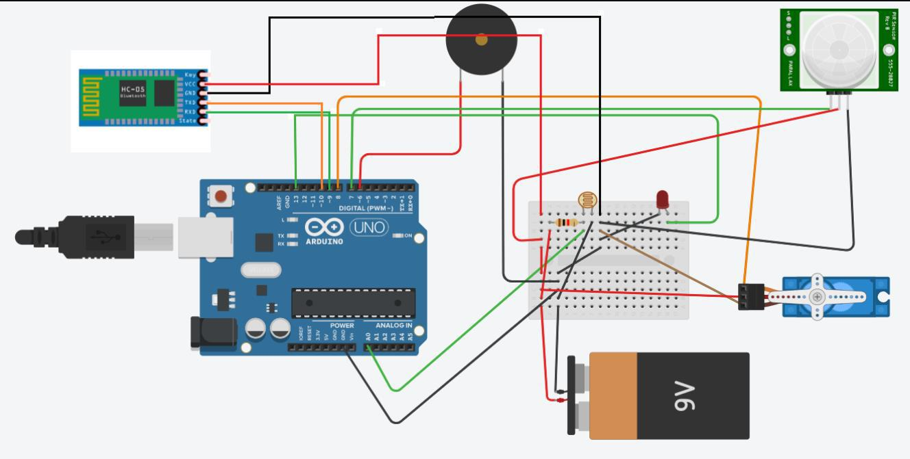

**4.4 SOURCE CODE: (ARDUINO)**

#include<SoftwareSerial.h>

#include<Servo.h>

#include<LiquidCrystal.h>

Servo servo;

LiquidCrystal lcd(12, 11, 5, 4, 3, 2);

int led = 13;

int buzzer = 6;

int pin = 7;

int ldr = A0;

int bluetoothTx = 10;

int bluetoothRx = 9;

int Contrast = 75;

int value = 0;

int pirState = LOW;

int right = 123;

int lighton = 2;

int lightoff = 9;

int ldron = 3;

int ldroff = 8;

int on = 1;

int off = 0;

int number = 0;

SoftwareSerial bluetooth(bluetoothTx, bluetoothRx);

void setup()

{

pinMode(ldr, INPUT);

pinMode(led, OUTPUT);

pinMode(pin, INPUT);

servo.attach(8);

servo.write(0);

delay(2000);

Serial.begin(9600);

bluetooth.begin(9600);

/*lcd.clear();

analogWrite(6, Contrast);

lcd.begin(16, 2);*/

}

void loop() {

if (bluetooth.available() > 0)

{

number = bluetooth.read();

Serial.println(number);

if (number == right)

{

servo.write(90);

delay(4000);

/*lcd.setCursor(0, 0);

lcd.print("Door-Unlocked");

lcd.setCursor(0, 1);

lcd.print("Welcome");

delay(5000);

lcd.clear();

lcd.setCursor(0, 0);

lcd.print("Prankishor is");

lcd.setCursor(0, 1);

lcd.print("King");

delay(5000);

lcd.clear();*/

servo.write(0);

Serial.println("Unlocked");

}

else if (number == on)

{

while (number == on)

{

value = digitalRead(pin);

if (value == HIGH) {

bluetooth.write("1");

digitalWrite(led, HIGH);

tone(buzzer, 450);

delay(5000);

noTone(buzzer);

delay(500);

if (pirState == LOW) {

Serial.println("Motion Dectected");

pirState = HIGH;

}

}

else {

digitalWrite(led, LOW);

noTone(buzzer);

if (pirState == HIGH) {

Serial.println("Motion Ended");

}

}

}

}

else if (number == off)

{

//TURN OFF PIR SEnsor

digitalWrite(led, LOW);

}

else if (number == lighton)

{

digitalWrite(led, HIGH);

}

else if (number == lightoff)

{

digitalWrite(led, LOW);

}

else if (number == ldron)

{

//ldron

while (number == ldron)

{

int ldrStatus = analogRead(ldr);

if (ldrStatus <= 800) {

digitalWrite(led, LOW);

Serial.println("Led is off cause its daytime");

break;

}

else {

digitalWrite(led, HIGH);

Serial.println("led is on cause its dark");

}

}

}

else if (number == ldroff)

{

//ldr off

digitalWrite(led, LOW);

}

else

{

Serial.println("Invalid");

}

}

}

**REFERENCES**

* [www.google.com](http://www.google.com/)
* <https://www.pantechsolutions.net/blog/iot-projects-for-engineering-students/>
* Wikipedia
* <https://electronicsforu.com/iot-projects-ideas>
* [www.youtube.com](http://www.youtube.com/)
* <https://www.intel.in/content/www/in/en/internet-of-things/overview.html>
* Google Patents

33